**Login and Registration**

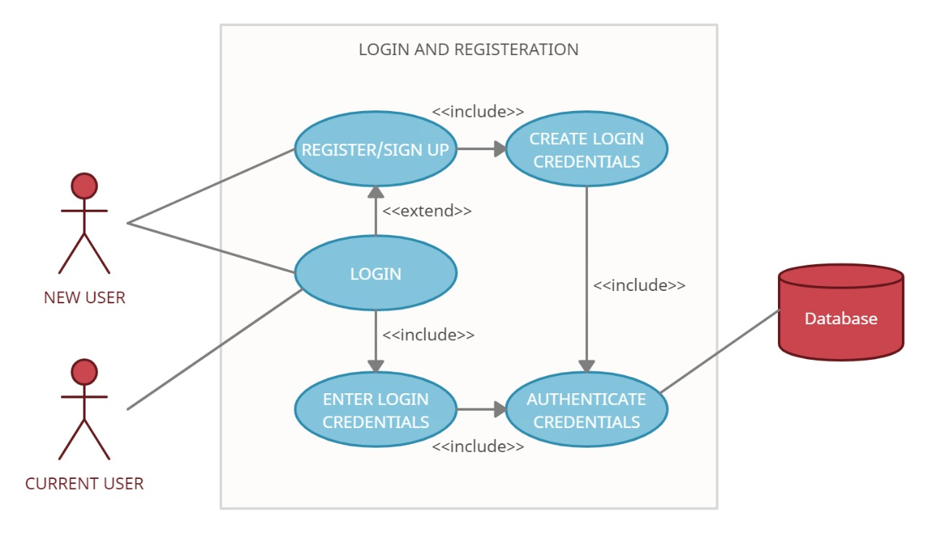

|  |  |
| --- | --- |
| Brief Description | Login and Registration |
| Basic Flow | This use case describes how a user logs in or register in to the system   1. The user has to register himself into the system. 2. After the successful registration, student types his/her name and password on the login form. 3. The system validates the student’s password and logs him/her into the system. 4. The student can search for the available books and the books which were taken by themselves are visible to them. 5. When user press Logout Button the page will redirect to Login page.  * User Id * Password * Name * Mobile Number * Email Id * DOB * State * City * Pin Code * Full Address |
| Alternate Flow | 1. If the system cannot find the textbox field empty or invalid, then it displays the error message on the screen. |
| Validation | 1. The Name shouldn’t be empty. 2. The DOB should contain a valid date format (dd/mm/yyyy) and should not be empty. 3. The Contact no should not be empty and it shouldn’t exceed the length 10 and it should not be empty. 4. The Email should be letters with @ and dot and it should not be empty. 5. The State should not be empty. 6. The City should not be empty. 7. The Pincode should not exceed the length 6 and it should not be empty. 8. The Address should not be empty and it should not exceed the length 80. 9. The Member id should not exceed length 4 and it should not be empty. 10. The Password should contain at least one uppercase, one lowercase and one special character and it should not be empty. |
| Pre-Conditions | User should have network access and Browser with latest updates. |
| Post-Conditions | Student Dashboard will be shown. |

**Wireframe for Login:**

**Log In Page**

|  |  |
| --- | --- |
| **Username** | textbox |
| **Password** | textbox |

Login

Signup

Forgot Password

**Registration Page**

|  |  |
| --- | --- |
| **Name** | textbox |
| **Mobile number** | textbox |
| **Email** | textbox |
| **DOB** | textbox |
| **State** | textbox |
| **City** | textbox |
| **Pincode** | textbox |
| **Full Address** | textbox |
| **Member Id** | textbox |
| **Password** | textbox |

Submit